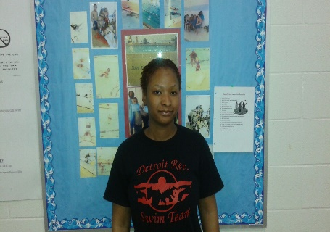

Name: Shde’ Gentry

Job Title: Lifeguard

Organization: City of Detroit’s Recreation Department

Location: Heilmann Recreation Center

Contact Number: 313- 224-9334

Email: shdegentry@yahoo.com

Question 1: What is your current role?
Answer 1: My current role is to ensure adequate water surveillance while providing excellent customer satisfaction on behalf of the City of Detroit’s Department of Parks and Recreation.

Question 2: Who are you in charge of?
Answer 2: I am not in a supervisory position, therefore I do not have any subordinates.

Question 3: Who do you report to?
Answer 3: I report to the Heilmann Recreation Center Supervisor – Byron Spivey

Question 4: What are your hours?
Answer 4: I work approximately 20 hours per week. Tuesday 1:00pm-5:00pm, Wednesday and Friday 5:00pm-9:00pm and Saturday 10am-6pm.

Question 5: What are your primary responsibilities?
Answer 5: My primary responsibilities are pool/pool office safety and cleanliness, and to prevent and/or take care of water related injuries as well as to perform rescue techniques when necessary.

Question 6: What perks do you have?
Answer 6: My perks consist of access to water and non-water related activities at the Heilmann Recreation Center. I am also able to use the commodities available by the facility outside my work schedule.

Question 7: Where did you receive your education from?
Answer 7: I received a Bachelor’s Degree in Business with a concentration in Accounting from Marygrove College in Detroit, MI.

Question 8: Where else have you worked and did you intern anywhere?
Answer 8: I have had the pleasure of working at other City of Detroit’s Recreation Centers, such as the Adams Butzel Recreation Center. I have also worked at Nikki’s Bar and Grille and Lucky’s nightclub and lounge. I interned at the Plymouth Educational Center Preparatory High School.

Question 9: What is it that you like and dislike about your position?
Answer 9: I love to teach swim lessons to all ages. I dislike the pay rate for the lifeguard position, particularly with the considerable amount of experience that I possess.

Question 10: What advice would you give in regards to getting into the recreation industry?
Answer: 10: The advice that I would give in regards to getting into the recreation industry is that, if you are not a “people person,” working in parks and recreation is definitely not the field that I’d suggest one to pursue. Particularly, if you are not fond of children. Children are our primary patrons; so one must enjoy working with kids in this industry. Also, if you have some sort of degree, I would suggest that one apply for positions that requires degrees. They may have a better chance of getting better pay.

